

Custom OTL Pending Timecard Report for Daily Time Entries
March 2026

Disclaimer
The described solutions, options may differ based on the Fusion Cloud application versions. Practice the proof of concept (POC) on your development environment before providing the solution to clients.

Table of Contents
Introduction 4
Report Development 4
Report Security 5
Prerequisites 6

Introduction
This document is intended to provide the detailed solution on the Custom OTL Pending Timecard BIP Report.

The Pending Timecard Report gives the details of the pending time change requests to be approved by the line managers. The employees enter the time change request for each day using the Daily Time Entry option. This time change request is displayed as the pending request until approved by their managers.

Report Development
A custom BIP Report is developed using the below SQL query.
The Report includes the following 4 columns:
- Employee Name
- Date
- Timecard Type
- Hours

The report can be run by any manager on ad hoc basis to see the pending requests of their reportees only.

A scheduled report can also be developed which will have the information of the time change requests pending for approval for the employee who report to that manager or the manager above in the hierarchy. This would require addition of bursting logic in the data model. The employee data can be sent in the email body to the manager’s email address with the addition of the following bursting logic and a rtf template attached in the report.
The rtf template can be designed in the below format. The hyperlink below can be added in the template to enable the managers to directly go to the application.

Report Security
Report security has also been provided at report level to restrict access for all the users. Only users with below roles will be able to access and run the report.

- Payroll Manager
- Line Manger

On Report and Analytics Page: Select the Report.
Click More Permissions.
Add the required roles and set permission to ‘Open’.
Additional Security is provided at code level where the Secured View is added in the code and person id is linked with the manager id. The code also verifies the user id of the user running the report and validates the roles assigned to them.

The below exist clause is added in the report query which determines the user to be able to see the output. The “HRC_SESSION_UTIL.GET_USER_PERSONID” returns the user id running the report. This user id is validated against the manager id. If the user is the line manager, the report will display the data of its subordinates.

In other case of the exist clause, the user id is compared with the person id. If the user has the respective roles mentioned below, the report will display all the employee records in the system with pending time change requests.

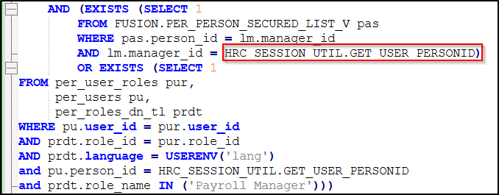

If the role is ‘Line Manager’, the users will see their reportees data only. If the role is ‘Payroll Manager’, the user will be able to see all the records.

Prerequisites
The employee would enter the timecard using the Daily Time Entry option provided in their profiles. Navigation to access this option is:

Me Time and Absences Daily Time Entry

